// **Half Subtractor**

module half_sub(input ha,hb, output hby,hd);

assign hd = ha ^ hb;

assign hby = ~(ha) & hb;

endmodule

// **Full Subtractor**

module full_sub(input a,b,c, output by,d);

wire x,y,z;

half_sub hs1(a,b,x,y);

half_sub hs2(y,c,z,d);

or(by,z,x);

endmodule

//**Testbench**

**module sub_tb();**

**reg a,b,c;**

**wire by,d;**

**integer i;**

**full_sub DUT(a,b,c,by,d);**

**initial**

**begin**

**$monitor("@time: %3d : a is %b, b is %b, c is %b where difference is %b and borrow is %b", $time, a,b,c,d,by);**

**for (i = 0 ; i <8 ; i = i+1)**

**begin**

**{a,b,c} = i;**

**#10;**

**end**

**end**

**endmodule**

**Waveform:**

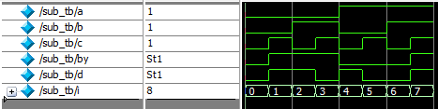

**Output:**

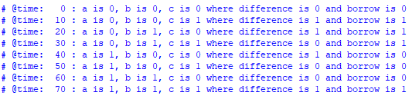

**RTL:**

